How do obesity and mental health mutually affect each other?

Doğukan Somuncu

Department of Information Systems and Technologies

University of Bilkent

Çankaya, Ankara dogukan.somuncu@ug.bilkent.edu.tr Kutlucan Öztürk

Department of Information Systems and Technologies

University of Bilkent

Çankaya, Ankara

kutlucan.ozturk@ug.bilkent.edu.tr Gülce Özbek

Department of Information Systems and Technologies

University of Bilkent

Çankaya, Ankara

gulce.ozbek@ug.bilkent.edu.tr

**Abstract – Obesity continues to significantly impact individuals' quality of life, influenced by factors such as fast-food consumption, sedentary lifestyles, budget constraints, and time limitations. The onset of the COVID-19 pandemic triggered substantial lifestyle changes, including prolonged periods of confinement, heightened unemployment rates, and a marked decline in mental health. Our study delves into the intricate relationship between obesity and mental health, examining their bidirectional influence, particularly in consideration of various countries, gender variations, and the profound impact of Covid-19 on individuals' mental well-being since its onset.**

Index Terms—Obesity, Mental Health, World, Covid-19, Pandemic.

# Introduction

Obesity is a serious condition affecting people's lives negatively in many countries today. This situation can be attributed to various factors such as unhealthy eating habits, sedentary lifestyles, among others. In addition to the impact of mental health issues on obesity, obesity also affects mental health. While writing this report, our aim was to analyze obesity rates and rates related to mental health, specifically depression, based on age, gender, country, and years. Through our data analysis focused on this goal, we attempted to reveal whether there is a relationship between mental health and obesity. We strived to present our data analyses graphically and in written form to illustrate this relationship.

# HYPOTHESES

**H1: A positive correlation exists between obesity rates and the prevalence of depression across diverse demographics and nations.**

**H2: Gender differences shape the impact of obesity on mental well-being, resulting in distinct implications for mental health, particularly depression.**

**H3: Varied mental health effects of obesity are observed among different age groups, indicating diverse implications based on age demographics, particularly concerning depression.**

**H4: Socioeconomic factors act as moderators in the relationship between obesity and mental health, suggesting that variations in income or education levels might alter the strength of this correlation.**

# METHODOLOGY

Exploring the complex link between obesity and mental health across diverse groups requires a thorough and systematic approach. To begin, a detailed review of existing studies provides a foundation, allowing us to understand previous research methods, findings, and any gaps in knowledge. Next, gathering reliable data from

various sources that cover obesity rates, mental health indicators like depression prevalence, demographics such as age and gender, and socioeconomic factors like income and education becomes crucial. Employing advanced statistical techniques, like correlation analysis and regression models, helps us delve into the intricate relationship between obesity and mental health while considering other influential factors. Segmenting the analysis by demographics allows for a more nuanced understanding, uncovering potential variations in this connection across different population subsets. Additionally, investigating potential mediators or moderators, such as socioeconomic status, through specialized analyses helps shed light on their impact on the relationship between obesity and mental health. Ensuring ethical practices in data collection and privacy protection remains paramount throughout the study. Finally, interpreting the findings in the context of existing research aids in presenting a comprehensive report that outlines methodologies used, key discoveries, limitations, and recommendations for further studies or interventions.

# DESCRIPTIVE ANALYSIS

Table 1 represents the top 10 countries with the highest depression rates in the world for the year 2023. Conversely, Table 2 showcases the 10 countries with the lowest reported rates of depression for the same year. These tables have been formulated to analyze and compare the prevalence of depression across different nations.

**Number of Observations (n):** The total number of observations or data points in the dataset.

**Mean:** The average value obtained by dividing the sum of values in the dataset by the number of observations.

**Standard Deviation:** A measure of how spread out the values in the dataset are around the mean. A low standard deviation indicates that the values are concentrated around the mean, while a high standard deviation indicates that the values are more spread out.

**Median:** The middle value when all values in the dataset are arranged in ascending order. It represents the central point of the dataset.

**Trimmed Mean:** The mean calculated after excluding the lowest and highest values in the dataset to reduce the influence of outliers.

**Mean Absolute Deviation**: The average of the absolute differences between each data point and the mean. It measures the average deviation of data points from the mean, indicating how spread out the data is.

**Minimum Value:** The smallest value present in the dataset.

Maximum Value: The largest value present in the dataset.

**1st Quartile:** The value below which 25% of the data falls in the dataset when arranged in ascending order.

**3rd Quartile:** The value below which 75% of the data falls in the dataset when arranged in ascending order.

**Number of NAs**: The count of missing or empty data points in the dataset.

**Skewness:** A measure of the symmetry of the dataset's distribution. Positive skewness indicates a right-skewed distribution, while negative skewness indicates a left-skewed distribution.

**Kurtosis:** A measure of whether the dataset is peaked or flat compared to a normal distribution. High kurtosis indicates a sharper peak, while low kurtosis indicates a flatter distribution.

**Standard Error:** An estimate of the standard deviation of a sample statistic. It indicates the sample's representativeness of the population.

These data were analyzed using R and R Studio, and tables were created according to data.

|  |  |  |  |  |  |  |  |  |  |  |  |  |  |
| --- | --- | --- | --- | --- | --- | --- | --- | --- | --- | --- | --- | --- | --- |
| Number of observations (n) | Mean | Standard Deviation | Median | Trimmed Mean | Mean Absolute Deviation | Minimum value | Maximum value | 1st Quartile | 3rd Quartile | Number of NAs | Skewness | Kurtosis | Standard Error |
| 10 | 5.71 | 0.3697146 | 5.66625 | 5.761111 | 0.274281 | 5.25 | 6.52 | 5.4825 | 5.8475 | 0 | 0.8331111 | -0.3160872 | 0.116914 |

Table 1 Most Depressed Countries in the World (2023 – Top 10)

|  |  |  |  |  |  |  |  |  |  |  |  |  |  |
| --- | --- | --- | --- | --- | --- | --- | --- | --- | --- | --- | --- | --- | --- |
| Number of observations (n) | Mean | Standard Deviation | Median | Trimmed Mean | Mean Absolute Deviation | Minimum value | Maximum value | 1st Quartile | 3rd Quartile | Number of NAs | Skewness | Kurtosis | Standard Error |
| 10 | 2.408 | 0.2294825 | 2.455 | 2.4525 | 0.140847 | 1.83 | 2.63 | 2.3725 | 2.54 | 0 | -1.432762 | 1.189903 | 0.07256874 |

Table 2 Least Depressed Countries in the World (2023 – Lowest 10)

|  |  |  |  |  |  |  |  |  |  |  |  |  |  |
| --- | --- | --- | --- | --- | --- | --- | --- | --- | --- | --- | --- | --- | --- |
| Number of observations (n) | Mean | Standard Deviation | Median | Trimmed Mean | Mean Absolute Deviation | Minimum value | Maximum value | 1st Quartile | 3rd Quartile | Number of NAs | Skewness | Kurtosis | Standard Error |
| 9634 | 26.66014 | 7.376579 | 25.98 | 26.17938 | 6.849612 | 12.88 | 81.25 | 21.58 | 30.89 | 0 | 0.9020778 | 2.201371 | 0.07515393 |

Table 3 BMI Trends by Survey Year and Gender

|  |  |  |  |  |  |  |  |  |  |  |  |  |  |
| --- | --- | --- | --- | --- | --- | --- | --- | --- | --- | --- | --- | --- | --- |
| Number of observations (n) | Mean | Standard Deviation | Median | Trimmed Mean | Mean Absolute Deviation | Minimum value | Maximum value | 1st Quartile | 3rd Quartile | Number of NAs | Skewness | Kurtosis | Standard Error |
| 10000 | 26.66014 | 7.376579 | 25.98 | 26.17938 | 6.849612 | 12.88 | 81.25 | 21.58 | 30.89 | 366 | 0 | 0 | 0.07376579 |

Table 4 Mean BMI by Year and Days Mental Health Bad

# MENTAL HEALTH STATISTICS

Although our main focus of study is obesity, it's important to note that we can't solely attribute the rising depression rates to obesity when considering mental health. There are numerous contributing factors to this issue. When analyzing the data, some of the countries with the highest depression rates in Figure 1 draw particular attention. These include Greece, Palestine, and Ukraine. Greece holds the highest depression rate at 6.52%, while Palestine ranks fourth with 5.75%, and Ukraine ranks tenth at 5.25%. The direct visibility of these countries might not solely stem from obesity. Greece grapples with economic hardships, life anxieties, political turmoil, and significant unemployment. Moreover, both Palestine and Ukraine are actively involved in ongoing conflicts and wars.

Figure 1 Top 10 Countries with the Highest Depression Rates

Looking at Figure 2, we can identify countries with the lowest depression rates in 2023. Among these, Brunei, Myanmar, and Peru stand out for their lower rates. Brunei, despite its low depression rates, prompts the need to delve into factors influencing the community's mental health. Myanmar's history of political and social instability may have lasting implications for mental well-being. In Peru, grappling with economic and social challenges potentially contributes to mental health concerns.

Similarly, countries like East Timor, Singapore, and Mali also demonstrate low depression rates, albeit with potentially differing underlying reasons. For instance, despite Singapore's elevated standard of living, the ways individuals cope with mental health

issues and the available support systems could play pivotal roles.

While nations like Colombia, Solomon Islands, and others showcase lower depression rates, each possesses its distinct social, economic, and political dynamics. Understanding the drivers behind these low depression rates holds key importance in shaping effective mental health policies.

The juxtaposition of lower depression rates across these countries underscores the intricate web of factors influencing mental health. Analyzing each country's unique circumstances and societal structures becomes imperative to grasp their specific 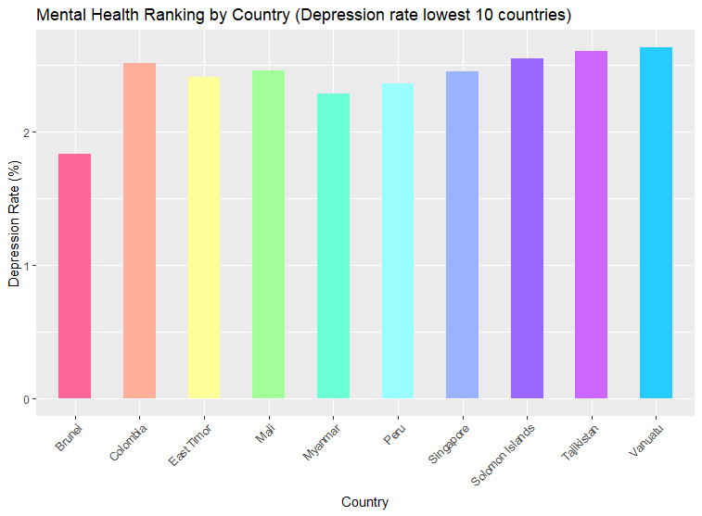impacts on depression and mental well-being.

Figure 2 Top 10 Countries with the Lowest Depression Rates

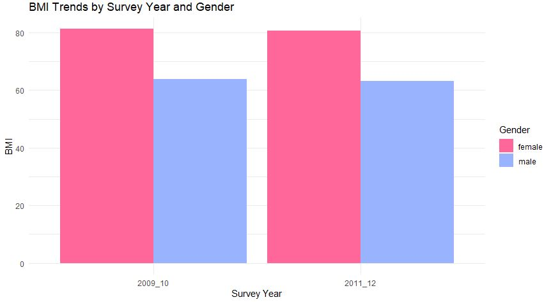

Figure 3 BMI Trends by Survey Year and Gender

The visual representation in Figure 3 unveils a notable pattern in BMI trends by Survey Year and Gender. Specifically, the color-coded bars indicate consistently higher BMI values for females compared to males across the surveyed years.

In examining the provided data, where the mean BMI is approximately 26.66 with a standard deviation of 7.38, a nuanced understanding of the relationship between BMI and gender emerges. This observation prompts a deeper exploration of potential gender-specific influences on mental health.

Figure 4 Mean BMI by Year and DaysMenHlthBad

The distinctive color patterns in the chart not only highlight the visual contrast in BMI distribution but also hint at the underlying association between gender and body mass index. The rightward skewness in the BMI distribution, indicated by a skewness value of 0.902, further accentuates this trend.

Understanding and addressing diverse mental health needs based on gender differences become imperative in light of these findings. Tailoring health interventions to recognize the unique challenges faced by individuals of different genders, such as societal expectations and cultural influences, becomes a crucial aspect of holistic healthcare strategies.

Moreover, the absence of missing values ensures the reliability of the dataset, and quartile values provide additional insights into the variability of BMI within the studied population.

In essence, Figure 3 not only captures BMI trends but serves as a visual narrative of the intricate interplay between BMI and gender. Recognizing these nuances is essential for crafting inclusive health strategies that cater to the diverse mental health needs of individuals across genders.

# DISCUSSION

Obesity not only affects physical health but also holds significant implications for mental well-being. Research in this field indicates that obesity has pronounced effects not only on the body but also on mental health.

The relationship between obesity and mental health is quite intricate. On one hand, obesity can heighten the risk of conditions such as depression, anxiety, and low self-esteem. Challenges related to body image, difficulties in social interactions, and societal stigmatization are factors that can trigger mental health issues associated with obesity.

Simultaneously, one's mental health condition can also contribute to the risk of obesity. For instance, being under stress, experiencing low moods, or resorting to unhealthy coping mechanisms to deal with emotional distress can lead to weight gain and escalate the risk of obesity.

The intricate interplay between BMI and mental health dynamics becomes evident in Figure 4. The color-coded representation of DaysMentalHealth provides a nuanced lens through which we can discern patterns and potential associations during the critical years of 2009 to 2011.

The substantial dip in mean BMI observed in 2010 aligns with specific DaysMentalHealth metrics, suggesting a potential correlation between mental health and body mass index during that particular year. This observation prompts a closer examination of the factors contributing to both mental health and BMI fluctuations.

While we don't have data for 2012 and 2014, the observed patterns during the focus years underscore the complex relationship between mental well-being and BMI, highlighting the multifaceted nature of these two aspects of health.

While the statistical measures provide a quantitative understanding of BMI distribution, the visual representation in Figure 4 allows for a more intuitive grasp of how mental health dynamics may have influenced fluctuations in mean BMI during the specified period. The color gradients offer a visual narrative, emphasizing the potential impact of mental health on weight management.

These findings underscore the importance of considering mental health as a crucial factor in the broader context of overall well-being, extending beyond physical health alone. Understanding the association between BMI and mental health during the specific timeframe of 2009 to 2011 contributes valuable insights for tailoring holistic health interventions and strategies addressing both physical and mental aspects of wellness.

This reciprocal interaction between obesity and mental health holds crucial implications for treatment and management. Addressing obesity may not solely involve physical factors but also considerations of emotional and psychological aspects. Therefore, supporting an individual's mental health alongside obesity treatment and fostering collaboration with mental health professionals could enhance the effectiveness of treatment processes and facilitate individuals in transitioning to a healthier lifestyle.

The Covid-19 pandemic has ushered in a period where movement is restricted, with people largely confined to their homes due to various restrictions and quarantines. This circumstance has significantly reduced physical activity and led to a sedentary lifestyle due to the limited living spaces. Challenges in accessing gyms, restrictions on outdoor activities, and the general confinement to homes have all contributed to a decrease in physical activity. Such a sedentary lifestyle could potentially increase the risk of obesity as the opportunity for regular exercise diminishes while sedentary behaviors increase.

Furthermore, the pandemic has impacted financial stability. Job losses, income reductions, and economic uncertainties have affected people's dietary habits. This could lead to a preference for more affordable, processed foods with longer shelf lives, which are often less healthy. Additionally, factors like stress, anxiety, and emotional eating might influence dietary choices, leading to an increase in unhealthy eating habits.

These circumstances may lead to reduced physical activity, unhealthy dietary choices, and consequently an increased risk of obesity during the pandemic. Therefore, encouraging physical activity, ensuring access to balanced nutrition, and providing support to those facing financial challenges are crucial. These measures can help mitigate the effects of the pandemic and alleviate health issues such as obesity.

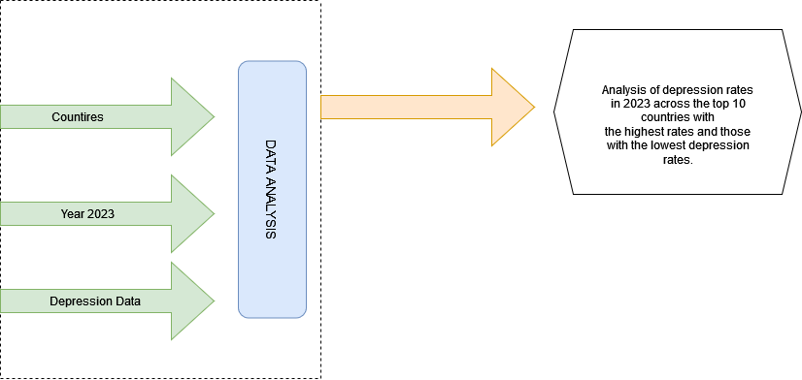

# Graphıcal abstract

# REFERENCES

[1] Wise Voter. (n.d.). Mental Health Ranking by Country. Wise Voter. Retrieved from <https://wisevoter.com/country-rankings/most-depressed-countries/#mental-health-ranking-by-country>